# **Prototype Report**

**Fooder**

**QWERTY**

**Jake Motta - Co-Lead Programmer, Graphics Designer**

**Alex Le - Project Manager, Co-Lead Programmer**

**Brendan Kao - Co-Lead Programmer, Tester**

**Jason Springer - Co-Lead Programmer, Quality Assurance**

# **Version History**

|  |  |  |  |  |
| --- | --- | --- | --- | --- |
| Date | Author | Version | Changes made | Rationale |
| 3/14/2017 | JM | 1.0 |  |  |
| 3/14/2017 | AL | 1.0 | Imported prototype 1.0 images and explained purpose of prototype report | To improve our understanding of software programming and prototype steps |
|  |  |  |  |  |

# 

# **Table of Contents**

Prototype Report........................................................................................................................... i

Version History................. ............................................................................................................ ii

Table of Contents......................................................................................................................... iii

Table of Tables............................................................................................................................. iv

Table of Figures............................................................................................................................ v

1. Introduction................................................................................................................................. 1

1.1 Purpose of the prototype report...................................................................................... 1

1.2 Status of the prototype.................................................................................................... 1

2. Navigation Flow.............................................................................................................................................. 2

3. Prototype...................................................................................................................................... 3

**Table of Tables**

Table 1: Main Application Page

Table 2: Bucket List Page

Table 3: Settings Page

# **Table of Figures**

Figure 1: Main Application Page

Figure 2: Bucket List Page

Figure 3: Settings Page

### **1.** **Introduction**

The purpose of the prototype report is to describe each version of our application “Fooder”. Currently, this report includes version one which has multiple pages of our application in separation.

This report will be continuously updated as our prototype is improved upon and our navigation path is built.

### **2.** **Navigation Flow**

Cannot fully apply navigation flow at this time since our prototype is not complete and all pages are not synchronized together.

### **3.** **Prototype**

Here includes our first three pages of our prototype. In this current version, we have still yet to include the synchronization of all these pages and how they are linked together. We have three stand alone pages for version 1.0.

Our goals will include to eventually include more pages and include the navigation flow was well as create a fully functioning prototype.

Figure 1: Main App Page

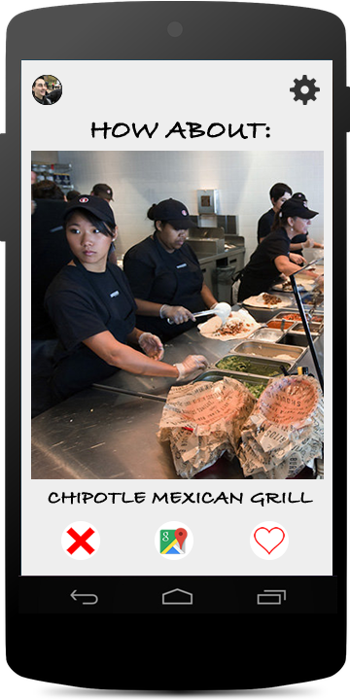

Table 1:Main_App

|  |  |
| --- | --- |
| Description | This screenshot is the main page of Fooder once a user starts to use it |
| Related Capability | Yelp API, Google API, Facebook API, Google Maps API |
| Pre-condition | There is no screen previously before this screen. Ideally, we wish to include a login page. |
| Post condition | Depending on user choice, if user swipes left or presses “x” the main page will refresh with a new restaurant image, if user swipes right or presses heart, notification will pop up showing it has been added to “bucket list” or favorites lists. |

Figure 2: Bucket List/ Favorites List

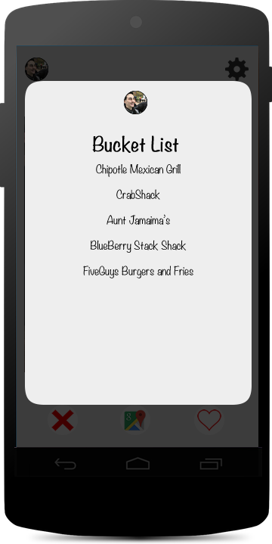

Table 2: Bucket List Page

|  |  |
| --- | --- |
| Description | This page is the user’s “bucket list” or favorites list which they can see all the restaurants that they’ve saved |
| Related Capability | Yelp API and application database storing user favorites |
| Pre-condition | User is logged in and has favorited at least one restaurant |
| Post condition | User can select restaurant from list to gather information about it. |

Figure 3: Settings Page

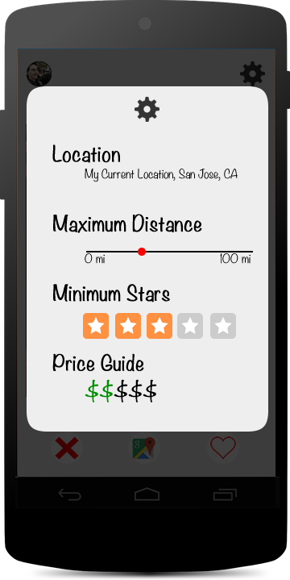

|  |  |
| --- | --- |
| Description | This page is the user’s settings which allow user to set distance, stars, and price |
| Related Capability | Yelp API and Google Maps API and location services |
| Pre-condition | User is logged in through facebook or google api |
| Post condition | User can set preferences before they search on the main page |